12 Transfer learning

This chapter covers
- Pre-training objectives
- Selecting training data
- Fine-tuning models
- Prompting
Please ignore grammar errors and typos. What you see is a raw manuscript; it has not been copyedited.
Let’s say you want to learn the e-guitar to join a rock band. Unfortunately, nobody offers e-guitar lessons anywhere close to your home. What do you do? Let’s assume your local music school offers lessons at least for the acoustic guitar. Not quite the same thing but somewhat close, isn’t it? So how about this strategy: you take weekly lessons in acoustic guitar over a year (hopefully improving your level), then take a one-week intensive seminar for learning the e-guitar somewhere else. The hope is that you’ll be able to transfer what you’ve learned playing the acoustic guitar to another, similar task, which is playing the e-guitar.
With an apology to the musicians among you for the simplifying analogy, the point here is that skills can be transferred across related tasks. That’s the idea behind Transfer Learning, the go-to approach for training large Transformer models such as GPT. Beyond sheer curiosity, knowing a little bit about the training process can help you when training or fine-tuning your own models, or when selecting between models, based on the way they’ve been trained. In this chapter, you’ll learn more about how transfer learning works for Transformer models. We discuss the pre-training stage (which trains the model on relatively generic tasks) and specialization methods such as prompting and fine-tuning in detail.

12.1 Transfer learning basics

Figure 12.1 Illustration of transfer learning: not finding any lessons for the e-guitar, we opt to learn the acoustic guitar first, then transfer to the e-guitar later.
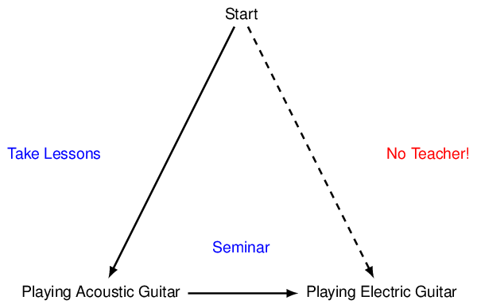

Up- understood
Let’s get back to our initial example: learning the acoustic guitar, then transferring to the e-guitar. Have a look at Figure 12.1 which illustrates that scenario. Starting at the node on top (meaning: we don’t know how to play e-guitar and we don’t know how to play acoustic guitar either), we can’t directly learn the e-guitar due to a lack of learning opportunities (that’s represented by the dashed line, connecting the node on top to the one on the bottom at the right-hand side). But what we can do instead, is to learn the acoustic guitar (that’s the line connecting the top node to the one below on the left) and then spend a moderate amount of time (the one-week seminar) to transfer from the acoustic to the e-guitar (that’s the line on the bottom, connecting the left to the right node).

Figure 12.2 Transfer learning in language models: training a large model to complete SQL queries often enables it to translate natural language questions into SQL with reduced need for task-specific training.
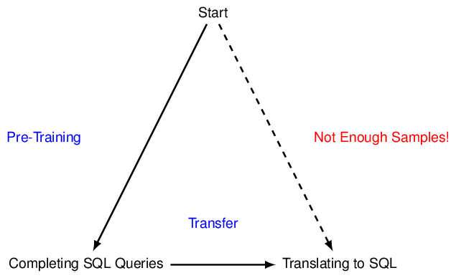
Up- understood

Language models don’t learn to play the guitar (not yet, at least, we might have to wait until GPT-6) but they do learn to process text and other data via a similar approach. Figure 12.2 shows an example that is a little bit more realistic, from the perspective of a language model. Let’s say our ultimate goal is to learn how to translate natural language questions into SQL queries (have a look at for details).
Now, models such as GPT are typically very large, meaning they have lots (i.e., often hundreds of billions) of parameters that we want to tune via learning. To do that, we would ideally like to have a lot of training data. As it so happens, we find quite a bit of training data for translating text questions into SQL queries. That’s because the problem has already been around for a while and people have generated training data with even thousands to ten thousands of examples (each example is typically a pair consisting of a question and an associated SQL query, translating that question). This training data has been perfectly sufficient to train pre-Transformer models, often significantly smaller than the models we see today. But is it enough to make the most out of those gigantic Transformer models we have nowadays? Probably not. And that’s why we might not want to train a Transformer model directly for translating text to SQL, using the rather anemic collection of training samples that are available for that specific task.
However, what we might want to do instead, is to train the model on a related task. Not quite translating questions to SQL queries but rather to complete SQL queries (i.e., given a prefix of a query, predict the next token). The advantage, here, is that we can easily find a lot of training data! We just search the Web to find sample queries from all kinds of tutorials, code repositories, and so on and so forth. Now, learning to complete SQL queries in general is certainly useful when writing SQL queries that translate specific questions. We may even find natural language comments in or around those queries, preparing the model better to handle natural language questions as well. While it is not precisely the task we’re interested in, the task of completing queries is related and we can easily find a lot of training data for it! After that, we can continue training with a moderate amount of task-specific training data (samples of questions and associated queries) in the hope that the model will additionally transfer insights it gained during generic training to the new task.

Figure 12.3 Transfer learning for language models: after pre-training on generic tasks, using large amounts of training data, language models are specialized for related tasks using moderate amounts of training data.
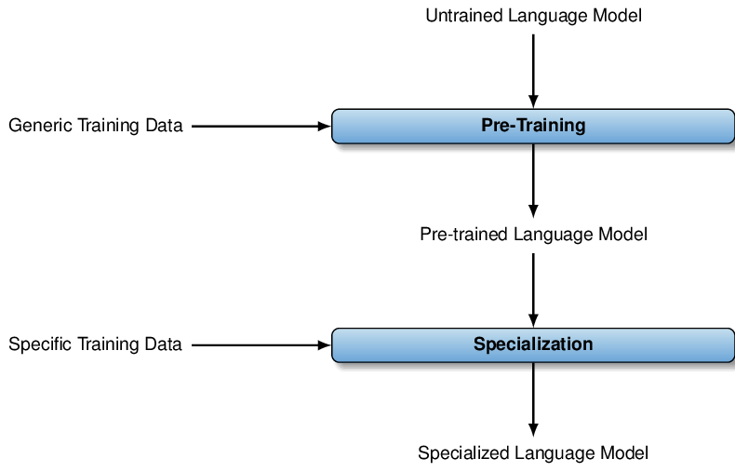
Up- understood

So, in summary: transfer learning means training a language model on a generic task first, using a large amount of generic training data, then using a (typically much smaller) amount of task-specific training data or merely a task-specific prompt for specialization. This process is illustrated in Figure 12.3. In the following, we’ll discuss each of the two steps, pre-training and specialization, in more detail.
Any comments on section 12.1 Transfer learning basics?

Up- understood

12.2 Pre-training
Imagine one of those big Transformer models before pre-training. Hundreds of billions of parameters, all of them randomly initialized. Those parameters determine, for instance, how queries, keys, and values are calculated for specific tokens in the context of attention mechanisms (have a look at the previous chapter to get more details on how attention mechanisms work). Having random weights means that any input text gets essentially mapped to random output. How do we get from there to something that we can have an interesting chat with? Something that writes code for us or classifies text? The first step is, of course, the pre-training phase.
We may not yet know which tasks a language models will be used for. Will users want to generate stories with it? Answer questions from text? Generate code for data processing? How do we know what to train for without knowing any specifics? Well, first of all, remember that we’ll rely on the ability of large language models to transfer knowledge from one task to a related one. That means we don’t have to train precisely for the task people will be interested in. It’s enough to train for a task that is somewhat similar. How could it be similar? Well, for starters, we might know that tasks relate to a certain language (be that either a natural language, such as English, or a formal language such as C++ or SQL). If so, we might want to start by giving the model a certain degree of language processing capabilities. That should come in handy, no matter which task we want to solve in that language, doesn’t it?

12.2.1 Pre-training tasks
Teaching language models something about the language they’ll be working in is a common principle in pre-training. If we want to train a model that excels at tasks related to English text (e.g., writing a story, answering questions, having a relaxed chat) we better train it on a large corpus with English text. Want a model that does very well at solving tasks in C++ (e.g., translating instructions into code, completing the start of a given C++ program, fixing bugs in code)? We might want to train it using data from a large code repository such as GitHub. And what if we want a model that can do both? Well, then we better mix in a little bit of code and a little bit of natural language text. Similarly, we use more diverse data if we want the model to converse not only in English but also in French and, perhaps, to write code not only in C++ but other common programming languages as well.

Figure 12.4 Causal modeling objective: during pre-training, the language model learns to predict the next token in arbitrary source text.
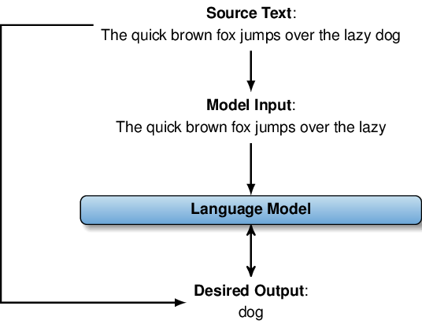

Up - understood
Ok, that seems reasonable: use training data that relates to the domain in which the language model should later operate. But what should we actually train it to do? Even if we have the data, what task should we teach it to solve with it? Well, over the years, people have tried quite a few different pre-training tasks. For instance, models like GPT are typically trained on a task called “causal language modeling”. What does that mean? Have a look at Figure 12.4 for an illustration. It shows how we get from a text sample (e.g., a single sentence like “The quick brown fox jumps over the lazy dog”) to a task: simply cut off the last token, then train the model to correctly predict it, given the text before the last token as input.
How does the actual training process work? We won’t go too much into detail here but, at a high level, the training process changes the values of model parameters that determine, for instance, how input gets mapped to queries, keys, and values in the attention mechanisms. This change happens gradually over time. For each considered training sample, we compare the output of the current model version to the desired output. For instance, for text output, we might compare the probability assigned to different tokens by the model to the ideal probability distribution. For the aforementioned task (predicting the next token), that ideal distribution assigns 100% to the right token and 0% to the others. We now try to slightly adapt the model parameter values in order to move the current output distribution one step closer to the ideal one. We repeat this process with different training samples (and possibly re-visiting previously considered samples later). After many iterations, the parameter values typically converge, meaning they don’t change that quickly anymore when considering new samples. At that point, we consider the model pre-trained.

Figure 12.5 Masked language modeling objective: during pre-training, the language model learns to predict obfuscated (masked) tokens in text.
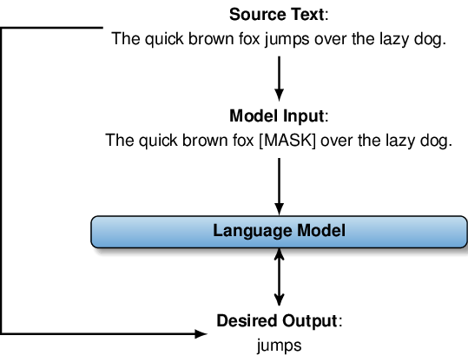

Up - understood
Causal language modeling (i.e., trying to predict the next token) is not the only pre-training task out there. Causal language modeling comes with a couple of restrictions. Most notably, we generally assume that all relevant information is contained in the text preceding the token where we want to make changes. That’s not really a great match for problems where we want to consider the context on both sides of the target token. For instance, consider the problem of debugging a given SQL query. Wouldn’t it be helpful to consider not only the text preceding the bug but also text that follows the faulty part? Wouldn’t that help to fix it? Indeed it would. And that motivates pre-training objectives teaching the model that it’s sometimes better to “look both ways” and integrate the full context.
So, perhaps we want to consider a different pre-training objective as well. Have a look at Figure 12.5. It illustrates an alternative pre-training objective: masked language modeling. Masked language modeling means, essentially, that we mask (i.e., “hide”) specific tokens in the input text. Then we ask the model to predict the missing token based on the full context, i.e., tokens that appear to the left and to the right of the masked token. Again, that’s a pre-training objective where we easily find large amounts of training data by downloading arbitrary sentences from the Web, for instance. We simply select a random token to hide, then use the original Web sentence to obtain ground truth. Take the example from Figure 12.5. Here, we found the sentence “The quick brown fox jumps over the lazy dog” on the Web, we decide to hide the word “jumps” and replace it with a special token (the [MASK] token indicates that a token was hidden). Then, we ask the model to predict the missing token. If the output is imperfect, we change the values of model parameters to make the correct output (“jumps”) more likely.
Masked language modeling is a popular pre-training objective. For instance, think back to the BERT model, the Transformer we discussed in the previous chapter. BERT is typically pre-trained using masked language modeling objectives¹. This is not an arbitrary choice. It has been shown that BERT, pre-trained using masked language modeling as opposed to causal language modeling, performs significantly better on tasks such as marking text passages that contain the answer to a given question (also called “extractive question answering”). Here, being able to use context to the left and to the right of the target passage (containing the preceding text as well as the question following the text) is clearly helpful.

Figure 12.6 Denoising objective: during pre-training, the language model learns to restore original text from a garbled version.
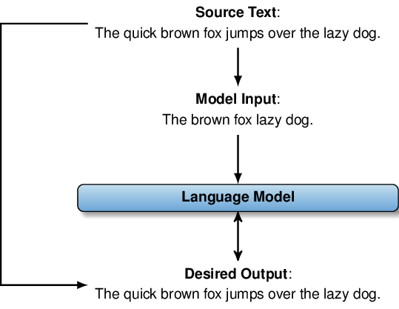

Up - understood
Using masked language modeling as pre-training objective enables models to perform well when specializing to tasks such as extractive question answering. On the other hand, it’s typically a bad idea if we are aiming for tasks where free-form text generation is important. After all, in masked language modeling, the model “knows” the number of hidden tokens it needs to predict. When generating text, however, we often don’t know in advance how many tokens we might want to generate. That motivates other pre-training objectives such as the denoising objective, illustrated in Figure 12.6. Again, we start with the same sentence as before: “The quick brown fox jumps over the lazy dog”. To generate a training sample, we introduce “noise” which can happen in one of several ways. Figure 12.6 focuses on the possibility of deleting random tokens in the input sentence. E.g., “The quick brown fox jumps over the lazy dog” turns into “The brown fox lazy dog”. The goal of the model is now to reconstruct the original sentence from the garbled version, i.e., the desired output is the original input sentence before introducing noise.
For instance, denoising is typically used for pre-training another popular Transformer model (which you will often find for download on online model repositories): the BART model. And no, that’s not a spelling mistake: BART is a different model than BERT and BART abbreviates Bidirectional and Auto-Regressive Transformer.
This should have been mentioned the first time BART was referred to – in the previous chapter.
Similar to BERT, it is able to integrate context from all directions (bidirectional), at the same time it uses auto-regression to generate text (meaning that it considers tokens it generated before to determine the next token in output text) and, of course, it’s a Transformer model. Compared to BERT, using a denoising objective during pre-training, it performs better at tasks that involve generating text (e.g., generating text summaries).
Let’s stop here and agree on a few key points about pre-training. First of all, you have seen that there are many possible tasks we can use to teach our models a bit of generic language understanding ability. But, second, the specific task we use may actually have an impact on the quality of the model when using it for more specific tasks down the line. While causal modeling seems to be the most popular pre-training objective for the latest generation of language models, you may find models trained with a different objective, offered by some providers (e.g., Huggingface). Depending on your task, it may pay off to compare models trained with different objectives (possibly after fine-tuning) to see which one results in optimal cost-quality tradeoffs for your task.

12.2.2 Pre-training data
The pre-training objective is only one out of two important design decisions when it comes to pre-training. The other decision is, of course, the selection of a training data corpus.
As a rule of thumb: large models go well together with large amounts of training data. After all, given an all too small data set, the large model may just use its vast amount of configurable parameters to learn the data “by heart” (an effect that is called “overfitting”). But then, the model would not have to learn useful patterns from the data that generalize to other inputs as well! Therefore, large language models such as GPT-3 (featuring 175 billion trainable parameters in the largest version) are typically trained on hundreds of gigabytes (to terabytes) of text.
Where do we find that kind of data? First of all, it seems pretty clear that manually creating data, specifically for model training, is prohibitively expensive at those scales. Therefore, we need to exploit existing data sets. One of the biggest sources of diverse text data is, of course, the Web. That’s why data corpora derived from Web text are very popular when it comes to the training of language models. But there is a problem: Web text is often of low quality, making it unsuitable to train models for high-quality output. Redundancy is another problem: certain text passages appear very frequently on the Web, making the data less diverse than we would ideally like. This is why recent language models are typically not trained on raw Web text but rather on carefully filtered subsets, possibly augmented by other sources of large amounts of text data.

Table 12.1 Mix of data sets used for training the GPT-3 model: the data set size (measured as the number of tokens) is not necessarily proportional to the weight (i.e., the frequency of training samples taken from the corresponding data set).
Common Crawl (Filtered+Deduplicated) | 410 Billion Tokens | 60%
WebText | 19 Billion Tokens | 22%
Books1 | 12 Billion Tokens | 8%
Books2 | 55 Billion Tokens | 8%
Wikipedia | 3 Billion Tokens | 3%
Up - understood
Take GPT-3 for instance, a recently released GPT version by OpenAI². Table 12.1 shows the data it was pre-trained on. As you see, it’s a mix of different data sets, each one corresponding to one row. In the second column, you see the size of each of the component data sets, measured by the number of tokens (so we’re talking about billions of tokens here!). The last column indicates the frequency at which we select samples from the corresponding data set for training. Intuitively, we might expect this number to be proportional to the relative sizes of the component data sets. But that’s not the case! Instead, the frequency at which samples from high-quality components are selected is higher than when selecting samples with equal probability from each component.
So what are the components that we mix together to get training data for GPT-3? Let’s go over all of them, one by one. First of all, we have the Common Crawl data set. What’s crawling here? Common Crawl is a non-profit organization that crawls the Web in regular intervals (every month, typically), making data extracted from all visited Web sites publicly available. The GPT-3 training data is based on data extracted between the years 2016 and 2019. Altogether, this amounts to 45 terabytes of text data! However, as discussed previously, lots of Web text is of low quality and, ideally, we want to filter out only the high-quality portions.
How can we actually do that? Manual filtering is clearly out of the question due to the amount of data. So, we have to filter data automatically. The idea here is to only keep text documents that are somewhat similar to other high-quality text documents. So, we use a first collection of high-quality documents as seed text, then train a simple classifier to contrast those documents from random text samples. That’s the first step of filtering (and we’ll discuss how to select those high-quality seed documents in a minute!). Besides that, we want to avoid keeping duplicate text. Even if two documents are similar (as opposed to being exactly equivalent) it’s less interesting to have both of them in our training data set. Hence, the GPT-3 training data is filtered by identifying “fuzzy duplicates”, meaning documents with a similarity above a threshold.
We still need to discuss how we select seed documents, used to train our classifier to recognize high-quality text. Ideally, we want to use documents that have been manually classified as high-quality text. We could start collecting data ourselves but there is a simpler (and much cheaper) option: there are online forums enabling users to post links that are then ranked (or liked or evaluated) by other users. Highly ranked links should give us a pretty good idea of what constitutes a “high-quality document”, according to the majority of users. That’s precisely the approach taken for GPT-3: to identify high-quality documents, we use links posted on the Reddit forum³ which received at least three “karma” (a measure of approval on that platform).

Figure 12.7 Training pipeline used for GPT-3: we use highly ranked links, posted on Reddit, to train a classifier for filtering out high-quality samples from the Common Crawl Web text corpus. Finally, the filtered documents are deduplicated to obtain a diverse, high-quality Web text corpus.
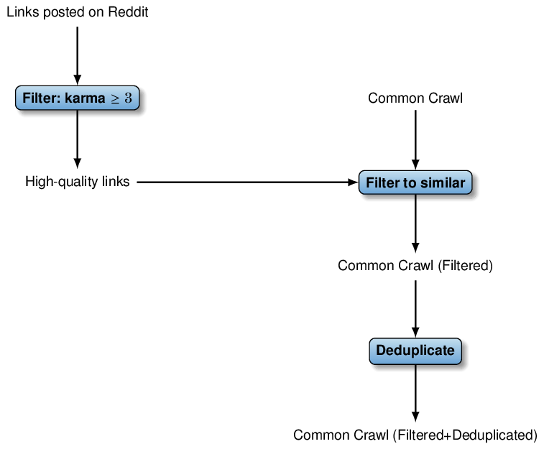

Up - understood
Besides using the resulting data to train a classifier (that is then used to filter the much larger Common Crawl corpus in a second step), the resulting documents are also directly included in the GPT-3 training data (that’s the WebText component in Table 12.1). Besides that, the training data contains two large collections of books (book text tends to be of higher quality than the average Web page, in the biased opinion of this book’s author) as well as the English version of Wikipedia. Again, Wikipedia is curated by a large set of authors and therefore of comparatively high quality. As you see, the frequency at which book text and Wikipedia articles are selected for training is much higher than the relative size of the associated components.
Figure 12.7 summarizes the training pipeline, generating the largest part of the training data for GPT-3: we rely on human feedback (karma votes) to identify high-quality links on the Web. Then, we use those as seed documents to train a classifier that then filters out similar documents from the Common Crawl Web corpus. The resulting documents are deduplicated and used for training.

Figure 12.8 Language models such as ChatGPT retain some information from data they use during the pre-training phase. So, when selecting data for pre-training, make sure it does not contain sensitive information as users of your model may be able to retrieve it!
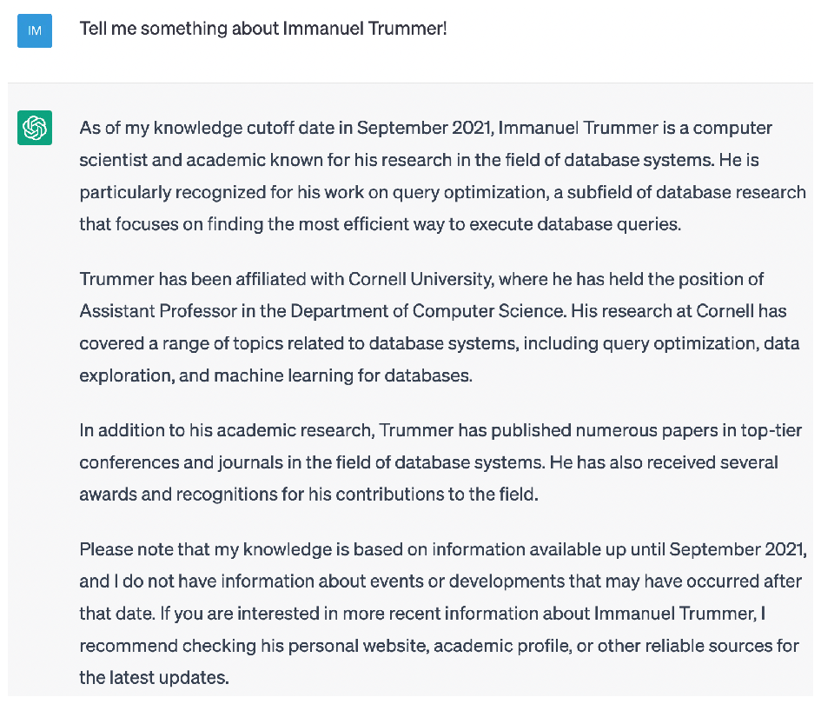

Up - understood
Pre-training GPT-3 only once costs millions of dollars. Rarely, if ever, will you find yourself in a position where you need to pre-train models of comparable size. However, especially when processing large amounts of data with a language model, you may very well want to pre-train a much smaller (and therefore more efficient) model that supports the range of tasks you are aiming for. If doing so, some of the ideas mentioned above may help you to generate a suitable data set for pre-training. In particular, you may want to use some of the aforementioned ideas to increase the quality of training data. For instance, if pre-training a language model from data that is internal to your company, consider exploiting any kind of human feedback (perhaps an internal ranking system) to filter text, possibly followed by an automated filtering stage that uses the aforementioned text as samples.
Quality considerations are not the only thing to pay attention to if you select your own training data. For instance, try asking ChatGPT for information about yourself or people you know of (have a look at Chapter 2 to see how to access it)! Chances are, given the vast amount of data ChatGPT has been trained on (which includes large parts of the Web), it may have come across some of those names. Now, of course, remembering factual information about specific persons is not directly the objective of pre-training for ChatGPT. However, as ChatGPT (as well as other GPT variants) are pre-trained for predicting the next token in text (causal language modeling), “remembering” some information about people helps, indirectly, in performing better at that task. E.g., predicting the next token in the sentence “Immanuel Trummer is living in” is easier if having some information on that person’s whereabouts. Have a look at Figure 12.8 to see what ChatGPT knows about the book author, all of which happens to be accurate. In general, don’t (really, don’t!) rely on information ChatGPT gives you about specific persons (or any other factual knowledge). In many cases, ChatGPT will just hallucinate information that may sound convincing but is not backed up by any real-world source. However, the example in Figure 12.8 (and, perhaps, the results of your own experiments) show that language models are, in principle, able to retain concrete, factual knowledge from the pre-training data.
What does that mean for selecting data sets for pre-training? Well, first of all, it means you want to make sure that your pre-training data does not contain any sensitive information. To take just one example: using a large corpus of medical files, not publicly available, for pre-training is probably a bad idea. After pre-training, users of the model may very well be able to extract information not about all but at least some concrete patients. Similarly, text containing passwords or other personal information is not recommended. Better assume that the language model may very well remember anything it finds in your data and act accordingly.
Sensitive information is not the only potential problem. You may also want to consider licenses associated with your training data. At the time of writing, the jury is still out on how licenses associated with the pre-training data relate to the trained model. Depending on your use case (and the outcome of pending trials), this may be an important consideration when selecting training data or models, trained based on specific data sets. Make sure you understand the constraints associated with your use case and whether or not specific models comply with it.

Figure 12.9 Description of XML Roberta model, describing its pre-training objective (masked language modeling) as well as the data it was pre-trained on (Common Crawl data).
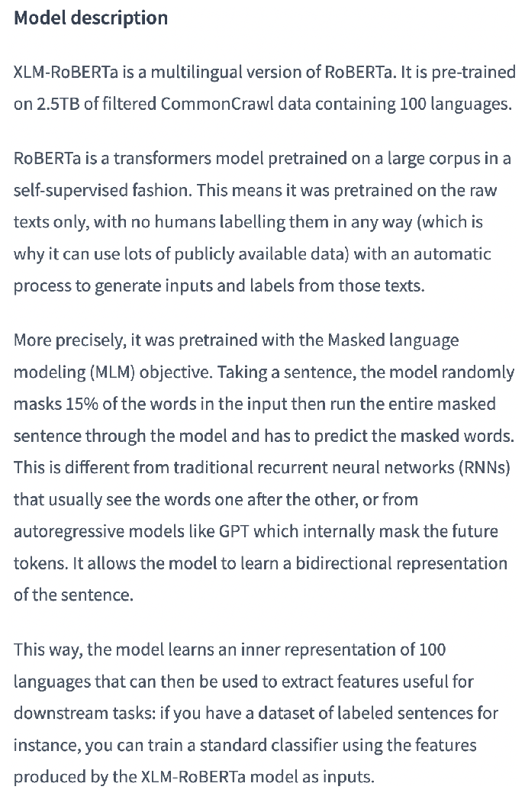

Up - understood
We have discussed pre-training in this section, about the most common pre-training objectives and about criteria and methods used to select the (necessarily large amounts of) training data. When selecting between language models for your data analysis task, you typically find detailed information about the way the model was pre-trained. E.g., have a look at Figure 12.9. It shows the description of the XML Roberta model, available on the Huggingface online repository⁴. The content in this section should enable you to make sense of the description of its pre-training objective (masked language modeling) as well as the data it was pre-trained on (the Common Crawl Web text corpus). Equally, if you train your own models, this section should give you a pretty good starting point in terms of criteria and methods.
Any comments on section 12.2 Pre-training?

Up - undertstood

12.3 Specialization
Okay, we have pre-trained a large language model such as GPT, using a huge amount of diverse text, and a generic pre-training objective (e.g., predicting the next token). Typically, we are not really interested in the task that pre-training focuses on. Instead, we want to use our model for much more specific tasks (e.g., classifying text or writing SQL queries). How do we get there? How can we specialize our model?
There are actually a few different possibilities, each with its own advantages and disadvantages, that we will all discuss in the following. If you have been reading the previous chapters, you have already used each of the variants discussed next. If you chose to start with the final chapters, i.e., going from principles to practice, no worries: we discuss all specialization methods in the following.
Have a look at Table 12.2 to see the most common variants. The specialization methods differ in terms of the amount of (now task-specific) training data you need (that’s the second column in Table 12.2). Also, they differ in terms of whether or not specialization involves actual training of the model (i.e., whether we want to change the values of model parameters during specialization).

Table 12.2 Options for specializing pre-trained language models for new tasks.
Fine-Tuning
Yes
Few-Shot Learning |  |  | 1 - 10 | No
Zero-Shot Learning |  |  | 0 | No
This table looks misaligned it needs column headings and table/cell borders. - CORRECTED

12.3.1 Fine-tuning
Let’s discuss those different specialization options in more detail. First of all, there is fine-tuning. The term, fine-tuning, is actually quite descriptive and gives you a sense of what’s happening here. We consider the pre-trained version of the model the raw version, then fine-tune it to make it better suited for whatever task we have in mind. Fine-tuning involves actually training the model. So you should have some training samples that represent the task you’re aiming for well. For instance, if you want to classify reviews into positive or negative reviews, based on the review text, you better provide samples that include pairs of a review text and the associated sentiment. Or, if you want to translate natural language questions into SQL queries, you should provide a collection of pairs, each one containing a natural language question and the associated SQL query. In general, provide data where the first component is a sample input, the second part is the desired output.
Fine-tuning means that we’re actually training the model, similar to what we did in the pre-training phase. Again, we’re feeding the model (the pre-trained version) sample input, then compare its current output to the desired output. If there is a deviation, we slightly change the values of model parameters to “move” it one step further into the right direction. To make that worthwhile, you should have at least a few hundreds of samples for fine-tuning.
At this point, you might be wondering: if we plan to train our model with task-specific data anyway, why would I ever want to go through the expensive pre-training stage? The answer is “sample efficiency”. Our hope is that the parameter values that are suitable to solve our target task are somewhat close to the ones that optimize performance for the pre-training objective. Therefore, having a good starting point from pre-training hopefully speeds up the fine-tuning phase. Typically, without pre-training, you would need not hundreds but at least tens of thousands of samples to do any meaningful training for tasks such as text-to-SQL translation. Also, whereas fine-tuning typically takes in the order of minutes for popular models such as BERT, it would be much more expensive to train a model from scratch for your target task! You can think of pre-training as a way to separate task-independent knowledge from the training process, thereby amortizing the associated costs over a large number of tasks and scenarios! Research shows that pre-training reduces the amount of task-specific data, needed to achieve state-of-the-art performance, by many orders of magnitude. That’s the reason why pre-training is used in virtually all applications of language models, nowadays.
In some cases, fine-tuning is applied directly to the model that results from pre-training, without any changes. For instance, if considering a decoder model, pre-trained to complete text, we can work with the same model to fine-tune it for generating text in a specific domain. On the other side, in some cases, we might actually want to add a little extra component to the model to make it suitable for solving other specific tasks.

Figure 12.10 Using BERT for text classification: the raw output of the BERT model is passed through a small post-processing component that maps the output vector associated with the [CLS] token to class probabilities.
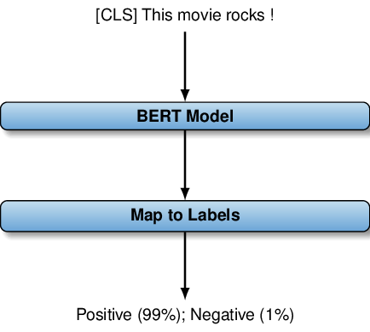

Up - understood
For instance, this approach is common when it comes to the BERT model (a Transformer model that we discussed in quite a bit of detail in the previous chapter). Let’s say we want to classify movie reviews into positive or negative reviews, depending on the review text. This is a text classification problem and we have two possible classes: positive (somebody liked the movie!) and negative (not worth the money). BERT is an encoder model that produces as output a vector for each of the input tokens. So how do we get from vectors to classes? Here, we need a little bit of extra infrastructure that realizes this mapping. Typically, for that, we use a component that transforms one of those output vectors into scores for all possible output classes (in this example, there are only two of them). We can then scale those scores to probabilities for each of the two output classes (and, if using the model for classification, we can simply take the class with maximal probability). So which output vector should we use for that? Typically, here, we use the output vector for the [CLS] token (which is automatically added for each BERT input).
During fine-tuning, we adapt not only the values of BERT’s original parameters but also the parameters related to the post-processing component (calculating class scores). Note that this setup is quite task-specific: even if we consider a different classification task, related to movie reviews, we would still have to change the post-processing component since our target classes have changed. At the same time, this limits the benefit of pre-training. Pre-training gives us a much better starting point than randomly selected values to find good settings for model parameters. But, of course, that only refers to parameters that are already present during the pre-training phase. Here, the post-processing is task-dependent and won’t benefit from pre-training. However, the number of parameters required for the post-processing component is typically much smaller than the number of parameters for the rest of the model. Therefore, pre-training still makes a huge difference for sample-efficiency.

Figure 12.11 Using BERT for question answering: the raw output of the BERT model is passed through a small post-processing component that maps the output vector associated with each input token to probabilities of being the start or the end of the text passage containing the question answer.
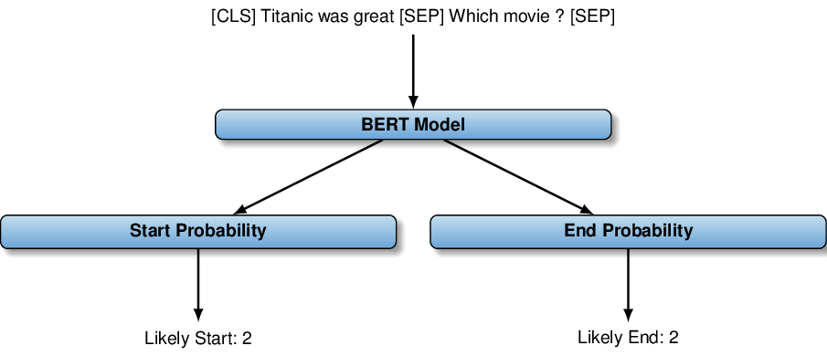

Up - understood
Let’s take another type of task, just to show you the range of possibilities for fine-tuning models like BERT. The task is extractive question answering. Here, we are given a text and a question. The goal is to identify a consecutive text passage in the input text that answers the input question. Have a look at Figure 12.11. Here, our input contains the source text (“Titanic was great”) as well as a question (“Which movie?”) that refers to the text. The right answer, the name of the relevant movie (“Titanic”), can be obtained by extracting part of the input text. Note that we use the [SEP] token to separate the source text from the corresponding question (and, as always for BERT, the start of the input is marked by the [CLS] token).
How can we use BERT for that? Again, we need to work with output vectors that BERT associates with each input token. This time we don’t want to map output vectors to class probabilities. Instead, we want to find out where the relevant text passage starts and where it ends. For that, we want to train two mapping components: one mapping per-token output vectors to scores, indicating how likely that token is to form the start of the answer passage. And then, you guessed it, we want to map tokens to their probability of being the end of the answer passage. Same principle as before: we have two task-specific post-processing components whose parameter values must be optimized via task-specific training. However, the number of task-specific parameters is again small, compared to the number of task-independent parameters, and pre-training is therefore still (very) helpful. In Figure 12.11, the highest scoring output for both post-processing components is the correct one (i.e., the second token, “Titanic”). If we want to cover cases in which the answer to the question is not actually contained in text, we can for instance use the [CLS] token, predicting no answer if its probability of being the start and end of the relevant passage is the highest one.
Ok, that’s fine-tuning for you: use parameter values obtained via pre-training as a starting point, then train a little more on task-specific data. Possibly, fine-tuning involves task-specific components but their size (measured by the number of parameters we want to tune) is small, compared to the size of the model as a whole.
Fine-tuning is very flexible. After all, we can update the value of each parameter of the model. This means we can get a model that is tailored for precisely the task we want it to solve well. On the other hand, there are a couple of important drawbacks. First of all, you need access to the model you want to fine-tune (in order to change its parameters). Being able to use a model and being able to fine-tune it are two separate things. For instance, large models such as GPT are often hosted on remote servers of providers such as OpenAI. Whether or not fine-tuning is an option then depends on the rules set by the provider. OpenAI enables fine-tuning for the majority of GPT versions but there are exceptions (e.g., GPT-4, the latest GPT version, is currently not available for fine-tuning).
Even if fine-tuning is possible, you may not want to use it. First of all, fine-tuning is often quite expensive, in particular for large models with many parameters. Fine-tuning requires applying the model to all training data for fine-tuning, then determining ways to adapt the model parameters in order to align them best with the desired output. This can take time and can cost non-negligible amounts of money. For instance, for OpenAI, you pay an amount that is proportional to the amount of data and to the number of iterations over the data (model parameters are optimized in each iteration) for fine-tuning. Also, after fine-tuning, you may have to pay higher per-token processing fees when using the fine-tuned model (after all, the model is now specialized for your scenario and therefore more “valuable”).
Perhaps even more importantly, fine-tuning requires a certain amount of training data to be applicable. This means, when targeting a novel task, you may first have to generate that training data yourself (or obtain samples from somewhere else, e.g., by hiring human annotators using a crowdsourcing platform). In any case, adapting to a new task via fine-tuning means computational, as well as other, overheads. Can’t we do better?

12.3.2 Prompting
Yes, we can! The newest generation of language models, including GPT as well as others, can typically be applied to novel tasks without any fine-tuning whatsoever! But how do we specialize the model for a new task if we can’t fine-tune? Easy: simply describe your task in natural language, as part of the model input! That’s an approach that we have already used, in fact. Think back to Chapter 2: how did we go about classifying text? Right: we simply described the classification task, along with the possible classes, as part of the problem input. More precisely, we used the input question “What is the sentiment behind this review (answer concisely, either "Positive" or "Negative")?”, followed by the review to classify.

Figure 12.12 Overview of GPT 3.5 versions: notice the reference to instruction following in the description of the text-davinci-003 version, indicating that the model is more suitable for zero-shot scenarios.
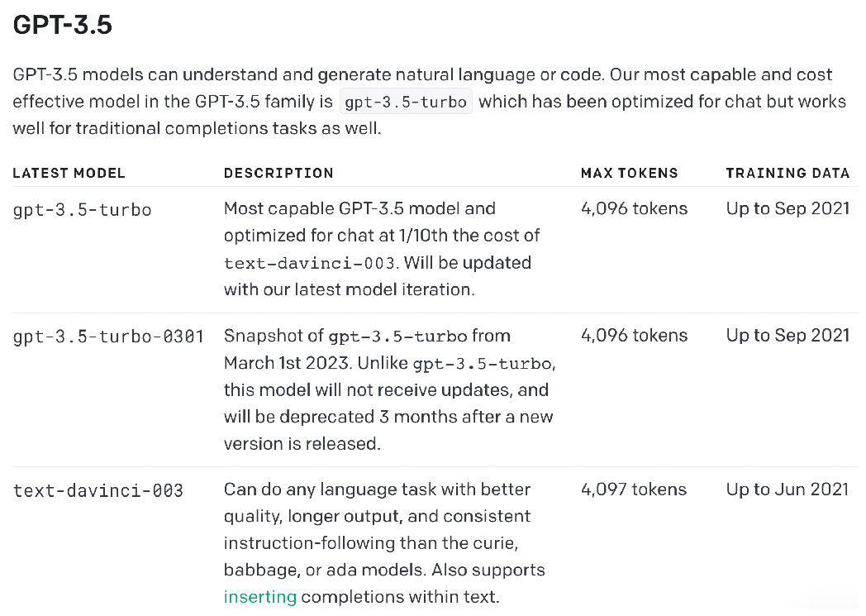

Up – understood.
This approach does not require any task-specific training samples and no change of model parameters, making it very fast to adapt to novel tasks! This approach is also called zero-shot learning as the number of training samples used is, exactly, zero. How well it works depends on the task and on the model. As a rule of thumb, at the time of writing, you will want to use one of the more recent models (e.g., recent versions of GPT) to make it work well. Ideally, use models that have been pre-trained for following instructions in natural language. For instance, several of the recent GPT versions have been pre-trained, in parts, using data that derives from interactions between human users and language models, instructing those language models to solve a variety of tasks. The resulting models tend to be better in zero-shot scenarios.
Have a look at Figure 12.12: it shows descriptions of alternative versions of the GPT-3.5 model. For instance, compare the description of text-davinci-003 and text-davinci-002.
I don’t see text-davinci-002 in the table.
You find a reference to instruction-following in one but not in the other. That means, if planning to use your model in zero-shot scenarios, you probably want to use the former.
Even when using the right model, it can be challenging to use models via tasks described in natural language alone. First of all, in some cases, it may be hard to describe all relevant requirements in natural language. For instance, if using a language model to generate code, you may have a hard time packing all details about the desired code style into a concise natural language command. Even if the task description is complete and accurate, for a complex task, it can be difficult even for the latest generation of language models to solve the task in all cases. This is why it is often useful to include examples, showing how to solve the task described in natural language on a few test cases, into the model input.
That approach is called few-shot learning (since we use few, rather than zero, training samples). Typically, adding even a few examples to the prompt can make a big difference for the success ratio of the model. In many cases, performance improves even when adding only one single example. For instance, if asking the model to classify reviews into positive and negative reviews, we could include pairs including a review and the appropriate class into the model input. Of course, this means we may have to generate a few training samples by hand for each new task. However, at least, we can reuse those training samples for every instance of the same task (even though, performance may improve if the provided samples are more similar to the specific task instance we want to solve).
Table 12.2 limits the number of training samples to ten for few-shot learning (this number should be understood as a rule of thumb, rather than an exact number). Why can’t we use more training samples, ideally the same number as with fine-tuning? We can’t include arbitrarily many samples into the model input due to the limited number of tokens that such models can process. Models like GPT can typically handle a few thousand tokens. OpenAI’s latest model, GPT-4, which is only available in the context of a limited beta test at the time of writing, can handle up to 32,000 tokens (the maximum among all GPT versions). As a rough guideline, each token corresponds to about four characters. This means providing tens of thousands of training samples, a reasonable number when using fine-tuning, won’t work with this approach. Of course, the maximal number of samples depends on the specifics of the problem (i.e., how many tokens it takes to describe one sample). However, in practice, this type of few-shot learning is typically used for up to around ten samples.
Even if few-shot learning works well, in terms of the output quality, you may still want to re-consider fine-tuning for different reasons. In particular, when using models such as GPT, the fees are typically proportional to the number of tokens processed. The number of tokens processed includes tokens read as well as tokens generated. When adding a task description and, possibly, examples to the model input, you pay for the added tokens in each model invocation. Of course, fine-tuning is expensive as well! However, it only happens once, then enables you to apply the fine-tuned model to every entry in a possibly large data set. Especially for large amounts of data, the added cost of fine-tuning may well pay off due to reduced per-instance processing costs. We will discuss the pros and cons of different specialization methods in more detail in the following chapters.
Any comments on section 12.3 Specialization?

12.4 Summary
- Transformer models are pre-trained on relatively generic tasks.
- Typically, those tasks make it easy to obtain large amounts of training data.
- Causal and masked language modeling and denoising are popular pre-training tasks.
- Causal language modeling aims at predicting the next token, given prior tokens.
- Masked language modeling aims at predicting masked tokens in text.
- Denoising aims at repairing text affected by different types of noise.
- Model performance for specific scenarios may depend on the pre-training task.
- Data for pre-training must be selected carefully, considering diverse criteria.
- Unsuitable pre-training data may cause privacy, legal, and performance issues.
- After pre-training, language models can be specialized for other tasks.
- Fine-tuning continues training with more task-specific training data.
- Prompting relies on a task description in the model input text alone.
- Both, fine-tuning and prompting, are useful in specific scenarios.
¹ More precisely, the actual pre-training objective combines masked language modeling and other objectives. For instance, this includes predicting whether two given sentences follow each other in the same text document.↩︎
² While the following paragraphs describe its training at a high level of abstraction, you can find more details in the paper “Language models are few-shot learners” by Brown et al.↩︎
³ https://www.reddit.com/↩︎
⁴ https://huggingface.co/xlm-roberta-base↩︎
What did you think of this chapter?
hide feedback

1
How many stars would you give this chapter?

3

2
What is your overall impression of this chapter?

? - This is a lot to digest in one reading. I think I get the general idea, but tough to fully comprehend without more examples and visualizations. For the sake of time, I continue and maybe revisit later.

